|  |  |
| --- | --- |
| Nama | : La Ode Muhammad Gazali |
| NIM | : 222212696 |
| Kelas | : 2KS2 |

**MODUL 13 PEMROGRAMAN BERORIENTASI OBJEK**

**(Networking Bagian 1)**

**Penugasan**

Laporkan hasil praktikum berikut dengan hasil penugasan dan penjelasannya ke Dosen dalam bentuk file pdf dengan format nama <<nim>>_modul13.

1. Lengkapi kode semua objek
2. Tangkapan layar hasil kode yang dilengkapi
3. Tangkapan layar hasil running

**Penyelesaian**

Buatlah project baru pada Netbeans dengan nama Latihan Server. Pada LatihanServer.java ikutilah kode berikut ini

**LatihanServer.java**

/*

 * Click nbfs://nbhost/SystemFileSystem/Templates/Licenses/license-default.txt to change this license

 * Click nbfs://nbhost/SystemFileSystem/Templates/Classes/Main.java to edit this template

 */

package latihan.server;

/**

 *

 * @author U53R

 */

import java.io.BufferedReader;

import java.io.IOException;

import java.io.InputStreamReader;

import java.io.PrintWriter;

import java.net.ServerSocket;

import java.net.Socket;

import java.util.logging.Level;

import java.util.logging.Logger;

public class LatihanServer {

    /**

    * @param args the command line arguments

    */

    public static void main(String[] args) {

        // TODO code application logic here

        int portNumber = 4444;

        try (

            ServerSocket serverSocket = new ServerSocket(portNumber);

            Socket clientSocket = serverSocket.accept();

            PrintWriter out = new PrintWriter(clientSocket.getOutputStream(), true);

            BufferedReader in = new BufferedReader(new InputStreamReader(clientSocket.getInputStream()));) {

            System.out.println("Server Receive: " + in.readLine());

            out.println("Pesan Diterima");

        } catch (IOException ex) {

            Logger.getLogger(LatihanServer.class.getName()).log(Level.SEVERE,null, ex);

        }

    }

}

Kemudian buatlah satu kelas baru bernama LatihanClient.java kemudian sesuaikan dengan kode di bawah ini

**LatihanClient.java**

/*

 * Click nbfs://nbhost/SystemFileSystem/Templates/Licenses/license-default.txt to change this license

 * Click nbfs://nbhost/SystemFileSystem/Templates/Classes/Class.java to edit this template

 */

package latihan.server;

/**

 *

 * @author U53R

 */

import java.io.BufferedReader;

import java.io.IOException;

import java.io.InputStreamReader;

import java.io.PrintWriter;

import java.net.Socket;

import java.util.logging.Level;

import java.util.logging.Logger;

public class LatihanClient {

    public static void main(String args[]){

        String hostName = "localhost";

        int portNumber = 4444;

        try (

            Socket echoSocket = new Socket(hostName, portNumber);

            PrintWriter out = new PrintWriter(echoSocket.getOutputStream(),true);

            BufferedReader in = new BufferedReader(new InputStreamReader(echoSocket.getInputStream()));

            BufferedReader stdIn = new BufferedReader(new InputStreamReader(System.in));){

            out.println("Halo");

            System.out.println("Client receive: "+ in.readLine());

        }catch (IOException ex) {

            Logger.getLogger(LatihanClient.class.getName()).log(Level.SEVERE,null, ex);

        }

    }

}

Maka ketika dijalankan, outputnya sebagai berikut:

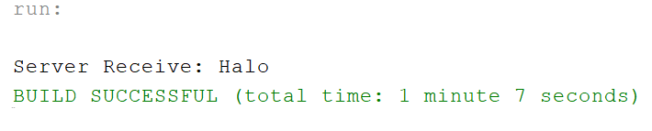

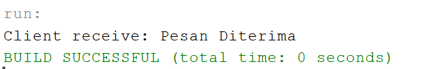

Kemudian kita modifikasi sedikit pada LatihanServer.java supaya server tetap menerima pesan hingga client mengetikkan teks tertentu:

**LatihanServer.java (Setelah modifikasi)**

/*

 * Click nbfs://nbhost/SystemFileSystem/Templates/Licenses/license-default.txt to change this license

 * Click nbfs://nbhost/SystemFileSystem/Templates/Classes/Main.java to edit this template

 */

package latihan.server;

/**

 *

 * @author U53R

 */

import java.io.BufferedReader;

import java.io.IOException;

import java.io.InputStreamReader;

import java.io.PrintWriter;

import java.net.ServerSocket;

import java.net.Socket;

import java.util.logging.Level;

import java.util.logging.Logger;

public class LatihanServer {

    /**

    * @param args the command line arguments

    */

    public static void main(String[] args) {

        // TODO code application logic here

        int portNumber = 4444;

        try (

            ServerSocket serverSocket = new ServerSocket(portNumber);

            Socket clientSocket = serverSocket.accept();

            PrintWriter out = new PrintWriter(clientSocket.getOutputStream(), true);

            BufferedReader in = new BufferedReader(new InputStreamReader(clientSocket.getInputStream()));) {

            String msg;

            while(!(msg = in.readLine()).equalsIgnoreCase("exit")){

                System.out.println("Server Receive: " + msg);

                out.println("Pesan Diterima");

           }

        } catch (IOException ex) {

            Logger.getLogger(LatihanServer.class.getName()).log(Level.SEVERE,null, ex);

        }

    }

}

Untuk LatihanClient.java dapat kita modifikasi menjadi berikut ini

**LatihanClient.java (Setelah modifikasi)**

/*

 * Click nbfs://nbhost/SystemFileSystem/Templates/Licenses/license-default.txt to change this license

 * Click nbfs://nbhost/SystemFileSystem/Templates/Classes/Class.java to edit this template

 */

package latihan.server;

/**

 *

 * @author U53R

 */

import java.io.BufferedReader;

import java.io.IOException;

import java.io.InputStreamReader;

import java.io.PrintWriter;

import java.net.Socket;

import java.util.logging.Level;

import java.util.logging.Logger;

public class LatihanClient {

    public static void main(String args[]){

        String hostName = "localhost";

        int portNumber = 4444;

        try (

            Socket echoSocket = new Socket(hostName, portNumber);

            PrintWriter out = new PrintWriter(echoSocket.getOutputStream(),true);

            BufferedReader in = new BufferedReader(new InputStreamReader(echoSocket.getInputStream()));

            BufferedReader stdIn = new BufferedReader(new InputStreamReader(System.in));){

            String msg;

            while((msg = stdIn.readLine()) != null){

                out.println(msg);

                if(msg.equalsIgnoreCase("exit")) break;

                System.out.println("Client receive: "+ in.readLine());

            }

        }catch (IOException ex) {

            Logger.getLogger(LatihanClient.class.getName()).log(Level.SEVERE,null, ex);

        }

    }

}

Jalankan LatihanServer.java kemudian jalankan juga LatihanClient.java. Kemudian ketikkan pesan dari Client ke server. Selama client idak menuliskan ”exit” maka client dapat terus mengirimkan pesan apapun ke server

**Client mengrim pesan ke server**

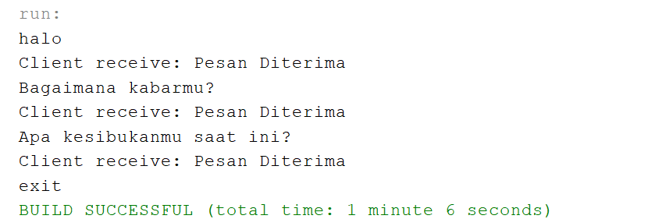

**Server menerima pesan dari clienr**

